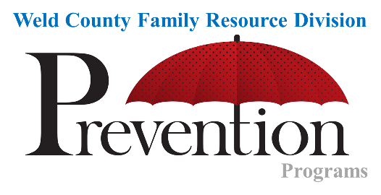

**Community Case Management Referral Form**

**THIS FORM IS *NOT* FOR CONCERNS OF CHILD ABUSE OR NEGLECT. IF A CONCERN REACHES THE LEVEL OF CHILD ABUSE OR NEGLECT, PLEASE CALL 1-844-CO-4-KIDS TO REPORT THE CONCERNS.**

|  |  |  |  |  |  |  |  |  |  |  |  |  |  |  |  |  |  |  |  |  |  |  |  |  |  |  |
| --- | --- | --- | --- | --- | --- | --- | --- | --- | --- | --- | --- | --- | --- | --- | --- | --- | --- | --- | --- | --- | --- | --- | --- | --- | --- | --- |
| **Identified Child ‘s Name:** | | | | | | |  | | | | | | | | **DOB:** | | | |  | | | | | | | |
| **Name of Caregiver:** | | | | | |  | | | | | | | | | **DOB:** | | | |  | | | | | | | |
| **Relation:** | | |  | | | | | | | | | | | | |  | | | | | | | | | | |
| **Other Adults/Caregivers in the Home (***Include DOB***):** | | | | | | | | | | | | | | | | | | | | | | | | | | |
|  | | | | | | | | | | | | | | | | | | | | | | | | | | |
| **Primary Address:** | | | | |  | | | | | | | | | | | | | | | | | | | |  | **Homeless?** |
| **City:** |  | | | | | | | | | **State:** | | CO | | | | | | | | | | | | |  | |
| **Zip:** |  | | | | | | | | |  | | | | | | | | | | | | | | | | |
| **Primary Phone Number:** | | | | | | |  | | | | | | | | | | | | |  | | | | | | |
| **Cell Phone Number:** | | | | | | |  | | | | | | | | **Contact:** | | | | | | |  | | | | |
| **Alternate Phone Number:** | | | | | | | | | | | | | | | **Contact:** | | | | | | |  | | | | |
| **Email Address:** | | | | | | | | | | | | | | | | | | | |  | | | | | | |
| **Preferred Language of Family:** | | | | | | | |  | **English** | |  | | **Spanish** | | | |  | | | | **Other:** | |  | | | |
| **School:** | |  | | | | | | | | | | | | **Grade:** | | | |  | | | | | | | | |
| **Referral Source:** | | | |  | | | | | | | | | | **Contact #:** | | | | | | |  | | | | | |
|  | | | |  | | | | | | | | | |  | | | | | | |  | | | | | |
| **How many children are currently in the home?** | | | | | | | | | | |  | | | | | | | | | | | | |  | | |
| **Other Children in the Home (***Include DOB***):** | | | | | | | | | | | | | | | | | | | | | | | | | | |
|  | | | | | | | | | | | | | | | | | | | | | | | | | | |

**Did you inform the family that you are referring them to the *Compass/Prevention* Program?**  Yes  No

Primary reason for initial referral:

**Assaultive**  **Delinquency  Disobedience**  **Gangs**  **Mental Health**

**Runaway**  **Substance Abuse  Suicidal**  **Truancy  Medical**

**Disability  Other:** Click or tap here to enter text.

|  |  |
| --- | --- |
| **Narrative:** |  |
|  | |
|  | |

**What Next:**

* Please email this completed form to HS-Prevention-Referral@co.weld.co.us
* The Prevention Team reviews all referrals to determine program eligibility once a week.
* If the referral is assigned, the Case Manager will contact the family to see if they would like services.