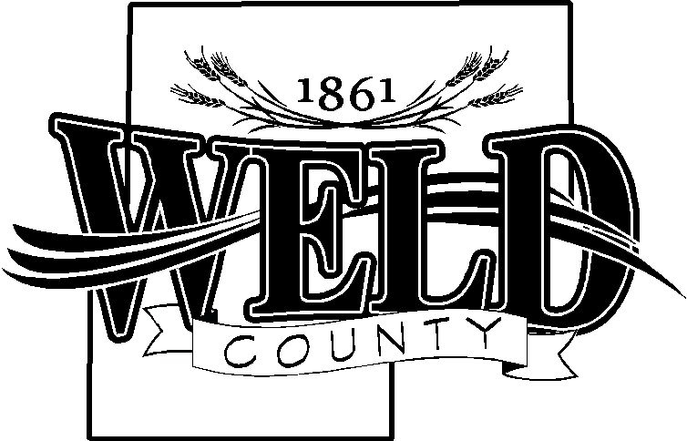

**OFFICE OF WELD COUNTY COUNCIL**

1150 O Street

P O BOX 758

GREELEY, COLORADO 80632

EMAIL: countycouncil@weldgov.com

PHONE: 970-400-4780

WEBSITE: www.weldgov.com

**WELD COUNTY COUNCIL**

**2021 – 4th Quarter**

**REPORT TO THE PEOPLE**

The Weld County Council is mandated in accordance with the Home Rule Charter of Weld County, Colorado, to report to the people of Weld County on a quarterly basis, those matters related to the council’s review of Weld County government. This report summarizes the activities of the Weld County Council during the fourth quarter of the calendar year 2021

**October 18, 2021**

*Extension Office-Hannah Swanbom*

Ms. Swanbom gave an overview of the department. She said with help from administration, the 4H program was upgraded to a new online platform. The goat extravaganza will be April 22-24, 2022, though she hopes it will soon expand to a four-day event. About 200 youth were certified in the meat quality program.

She said CSU has produced online safety training programs for those wishing to sell produce in public. They also went on a tour of the farm fresh areas in Weld County to view fruits and vegetables being produced.

The master garden program serviced more than 55 farmers markets last year and serviced nearly 400 clients in the office.

The extension office is fully staffed. The 4H recognition awards were held recently with more than 400 in attendance.

**November 15, 2021**

*Carly Koppes, County Clerk and Recorder*

Weld County Clerk and Recorder Carly Koppes and Rudy Santos, Chief Deputy, presented a general overview of their department. Mr. Santos is celebrating 20 years with the county.

They explained election preparation is a year-round responsibility, requiring monthly maintenance. Only a residential house can be used to actually register to vote. Ms. Koppes said non-US residents can get IDs, but they have a black box on there so they cannot be registered to vote.

Ms. Koppes said her department must be constantly diligent about new laws. She said election judges perform and conduct the election as it’s a citizen-based election process. They start building ballots when the election gets close.

She said Weld County has the most complicated ballot in the state because of so many municipalities, and fire, school, sewer and water districts.

Election processes must endure checks and balances conducted by someone other than the Clerk. Ballots are only mailed to active voters. Currently there are 208,000 active voters in Weld County.

Ms. Koppes explained voting machines are not used in Weld County or in Colorado. She said Colorado is a paper ballot state with ballot marking devices. Drop boxes are under 24-hour surveillance, with 17 available in the county. Envelopes by mail/drop off locations/drop boxes are tracked and residents can see progress online using ballottrax.com.

Ms. Koppes said by the time a ballot gets scanned for vote counting, it has been verified and cross checked seven times. The only thing that stops at 7 p.m. on election day is your ability to vote.

Each of Colorado’s 64 counties conducts its own independent election. Statewide audits are conducted based on multiple variables. The audits are meant to be as random as possible using mathematical equations. Ms. Koppes said her department continues to try and educate the public as there is so much mis/dis/mal-information circulating. Weld County is the gold standard nationwide and in Colorado when it comes to security of elections and voter access.

More specific information can be found at [www.weldvotes.com](http://www.weldvotes.com).

**December 20, 2021**

*Steve Moreno, County Commissioner*

Mr. Moreno gave an overview of happenings in the county during 2021. The final budget for 2022 was adopted at $375 million.

County employees were granted a 4 percent cost of living raise. An audit of tech positions, such as administrative assistants, showed those county employees in need of a raise to remain competitive, Mr. Moreno said. He said it’s especially important to remain competitive in the work force, especially now after the Covid pandemic.

The county received a total of $63 million in Covid relief funds. The county must determine by 2024 how those funds will be used.

The county has also seen a 39 percent reduction in oil and gas revenue. A huge expense facing the county will be the implementation of body worn cameras for law enforcement officers. Mr. Moreno said they anticipate that expense to be more than $1 million.

The county is in the process of replacing its communications system used by dispatch. It’s expected to be implemented by August.

Mr. Moreno explained the county has undergone staffing changes due to Covid, including having some employees work remotely, at least part-time. He said the workforce challenge has impacted not only the county, but also the private sector.

Infrastructure and transportation are always a priority for the county, Mr. Moreno said. He is especially proud the county is debt-free.

**WELD COUNTY COUNCIL**

_______________________________________

Council President Nancy Teksten

________________________________________

Council Vice-President Rupert Parchment

­­

________________________________________

Councilmember Tonya L. Van Beber

______________________________________

Councilmember James Welch

________________________________________

At-Large Vacancy Date Signed: February 28, 2022